|  |  |
| --- | --- |
| Date | 24 November2022 |
| TeamID | PNT2022TMID43214 |
| Project Name | AI-powered Nutrition Analyzer forFitnessEnthusiasts |

Apply Image DataGeneratorFunctionalitytoTrainsetAndTestset

LetusapplyImageDataGeneratorfunctionalitytoTrainsetandTestsetbyusing the following code

ForTrainingsetusingflow_from_directoryfunction.

This function will return batches of images from the subdirectories 'apples', 'banana','orange', 'pineapple', 'watermelon' together with labels 0 to 4{'apples': 0, 'banana': 1,'orange':2,'pineapple': 3,'watermelon': 4}

Arguments:

* directory: Directory where the data is located. If labels are "inferred", itshould contain subdirectories, each containing images for a class.

Otherwise,thedirectorystructureisignored.∙batch_size:Sizeofthebatches of data.Default:32.

* target_size:Sizetoresizeimagesaftertheyarereadfromdisk.∙

class_mode:

* ‘int': means that the labels are encoded as integers (e.g. forsparse_categorical_crossentropyloss).
* 'categorical'meansthatthelabelsareencodedasacategoricalvector(e.g.forcategorical_crossentropy loss).
* 'binary' means that the labels (there can be only 2) are encoded asfloat32 scalars with values 0 or 1 (e.g. for binary_crossentropy). - None (nolabels).

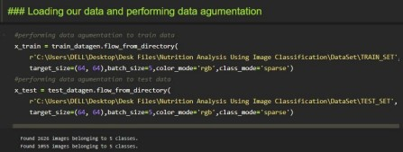

Wenoticethat2626imagesarebelongingto5classesfortrainingand1055imagesbelongto5classesfortestingpurposes.

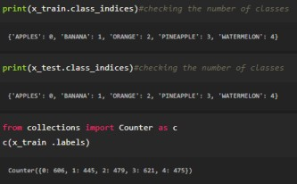

Here we are checking the number of classes in train and test data andcountingthenumberofimagesineachclassoftrainsetdatabyusingthe counter function.